Zero Trust Security Model – Assignment Answers

Task 1: Network Diagram

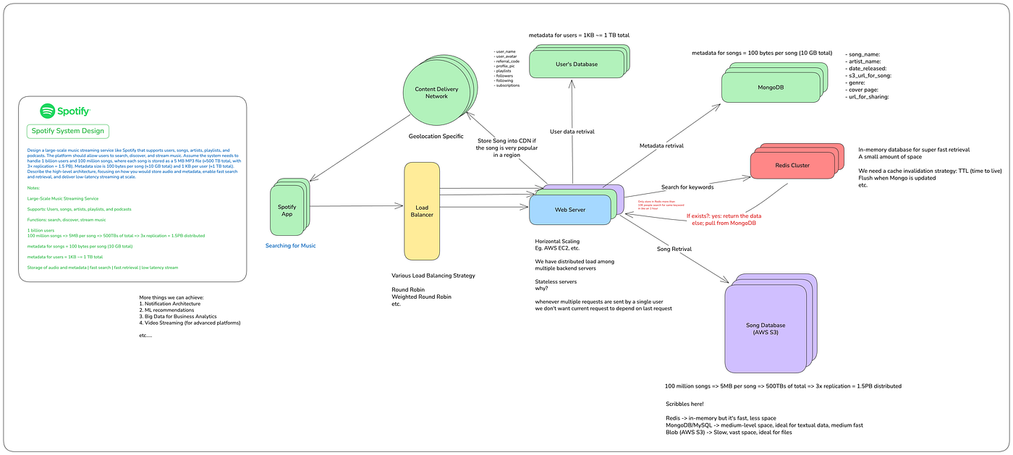
Network Segments:
- User Devices
- Web Servers
- User Database
- Admin Panel

Task 2: Zero Trust Access Policy
Admin Panel Access Policy
Role | Access | Minimum Privilege
Support Staff | Read-only user information | View customer accounts only
Software Engineers | Application deployment | No database access
Database Administrator | Database management | Database administration only
Security Administrator | Full security management | Manage firewall, IAM, logs
HR Staff | No Access | Denied
Security Controls
- MFA required.
- Device compliance check.
- VPN required.
- Role-Based Access Control (RBAC).
- Session timeout after 15 minutes.
- Continuous monitoring and logging.
This follows the Least Privilege Principle, where each user gets only the permissions necessary to perform their job.

Task 3: Micro-Segmentation
The User Database should be placed in its own isolated network segment.
Only:
- Application Servers
- Database Administrators
can communicate with it.
The Web Server should not connect directly to the database. All requests must go through the Application Server.
Benefits
1. Limits Lateral Movement
- If a Web Server is compromised, the attacker cannot directly access the database.
2. Improved Security
- Each segment has its own firewall policies and access controls, reducing the attack surface.
Compared to a flat network, micro-segmentation significantly improves containment and reduces the impact of breaches.

Task 4: Firewall Rule
In your diagram tool, add a firewall between the Web Server and Database.
Example rule:
Source | Destination | Port | Action
Web Server | Database | Any | Deny
Application Server | Database | 3306 | Allow
Admin Panel | Database | Any | Deny
Database | Internet | Any | Deny
Firewall Policy Example:
Rule 1:
Source: Web Server
Destination: Database
Port: Any
Action: DENY

Rule 2:
Source: Application Server
Destination: Database
Port: 3306 (MySQL)
Action: ALLOW

Rule 3:
Verify:
• MFA
• Device Compliance
• Identity Verification

